1.
A Project Report On

AI-BASED SMART CAREER RECOMMENDATION

Submitted in partial fulfilment of the requirement for the award of the degree

MASTER OF COMPUTER APPLICATION FROM

Marwadi University

Academic Year 2025 – 26

Ankit Kumar | (92500584110)
Ankush Kumar | (92500584141)

Internal Guide

Dr. Divyakant Thakarshibhai Meva



Rajkot-Morbi Road, At & PO: Gauridad, Rajkot 360 003. Gujarat. India.


Faculty of Computer Applications (FoCA)



This is to certify that the project work entitled

AI-BASED SMART CAREER RECOMMENDATION SYSTEM

submitted in partial fulfilment of the requirement for the award of the degree of

Master of Computer Application of the

Marwadi University

Is a result of the bonafide work carried out by

Ankit Kumar | (92500584110)
Ankush Kumar | (92500584141)

during the academic year 2025 – 2026

Dr. Divyakant Thakarshibhai Meva Dr. Sunil Bajeja Dr. Rijwan Khan

Faculty Guide HOD Dean CERTIFICATE

This is to certify that the project report entitled “AI-Based Smart Career Recommendation System” has been prepared by Ankush Kumar and Ankit Kumar as part of the academic requirements of the Master of Computer Applications (MCA) programme. The project presents a machine-learning based approach for recommending a career category from student-related academic, skill and profile attributes.

The documentation has been prepared from the supplied project notebook, application code, dataset, trained model artifacts and generated analytical outputs.

Project Guide: ______________________________

Head of Department: ________________________

Date: ______________________________________

DECLARATION

I, Ankush Kumar, and Ankit Kumar hereby declare that the project entitled (AI-Based Smart Career Recommendation System) is prepared for academic purposes. The technical description and results in this report are based on the supplied project implementation. The report does not present an artificial or assumed model performance; the evaluation values reported are those available in the supplied project.

Place: …………………………….
Date: …………………………

Ankit Kumar | (92500584141) | Signature: __________
Ankush Kumar | (92500584141) | Signature: __________

ACKNOWLEDGEMENT

It is indeed a great pleasure to express our thanks and gratitude to all those who helped us. No serious and lasting achievement or success one can ever achieve without the help of friendly guidance and co-operation of so many people involved in the work.

We are very thankful to our guide Dr. Divyakant Thakarshibhai Meva, the person who makes us to follow the right steps during our project work. We express our deep sense of gratitude to for his /her guidance, suggestions and expertise at every stage. A part from that his/her valuable and expertise suggestion during documentation of our report indeed help us a lot.

Thanks to our friend and colleague who have been a source of inspiration and motivation that helped to us during our project work.

We are heartily thankful to the Dean of our department Dr. Rijwan Khan for giving us an opportunity to work over this project and for their end-less and great support to all other people who directly or indirectly supported and help us to fulfil our task.

Ankit Kumar | (92500584110) | Signature: __________
Ankush Kumar | (92500584141) | Signature: __________

ABSTRACT

The AI-Based Smart Career Recommendation System is a machine-learning driven decisionsupport application designed to recommend a career category using student-related attributes. Career selection can be challenging because academic performance alone does not capture a student's technical skills, communication ability, problem-solving ability, project experience and other profile characteristics.

The supplied project contains a dataset of 100,000 records and 27 columns. The workflow includes data inspection, preprocessing, exploratory data analysis, feature transformation, supervised classification, model comparison and application-level prediction. The implemented models are Logistic Regression, Decision Tree and Random Forest.

The supplied evaluation reports 17.94% accuracy for Logistic Regression, 14.03% for Decision Tree and 17.22% for Random Forest. Random Forest records the highest F1-score among the three at 16.00%. These results establish a baseline for the current implementation and also show that substantial model improvement is required before the system can be considered a high-confidence career recommender.

CONTENTS

Chapter | Particulars | Page No.
1 | Certificate | 1
2 | Declaration | 1
3 | Acknowledgement | 1
4 | Abstract | 1
5 | List of Figures | 2
6 | List of Tables | 2
1 | Chapter 1 – Introduction | 2
1.1 | Background | 4
1.2 | Project Overview | 4
1.3 | Problem Statement | 4
1.4 | Objectives | 4
1.5 | Scope | 5
1.6 | Significance | 6
1.7 | Advantages | 6
1.8 | Limitations | 6
2 | Chapter 2 – Requirement Analysis | 7
2.1 | Functional Requirements | 8
2.2 | Non-Functional Requirements | 8
2.3 | Hardware Requirements | 10
2.4 | Software Requirements | 14
2.5 | Dataset Requirements | 15
2.6 | User Requirements | 16
3 | Chapter 3 – System Design | 18
3.1 | System Architecture | 22
3.2 | Data Flow | 23
3.3 | Machine Learning Workflow | 24
3.4 | Module Design | 25
3.5 | Prediction Logic | 26
3.6 | Security and Validation Considerations | 27
4 | Chapter 4 – Development and Implementation | 28
4.1 | Technology Stack | 29
4.2 | Dataset Loading | 30
4.3 | Pre-processing | 31
4.5 | Exploratory Data Analysis | 31
4.6 | Model Training | 33
4.7 | Model Evaluation | 34
4.8 | Application Layer | 34
4.9 | Saved Artifacts | 35
5 | Chapter 5 – Testing and Results | 36
5.1 | Testing Strategy | 35
5.2 | Test Cases | 37
5.3 | Model Comparison | 37
5.4 | Confusion Matrix | 38
5.5 | Feature Analysis | 38
5.6 | Sample Recommendation | 39
5.7 | Result Interpretation | 39
6 | Chapter 6 – Proposed Enhancements | 40
6.1 | Data Improvements | 42
6.2 | Model Improvements | 41
6.3 | Recommendation Features | 42
6.4 | Deployment Improvements | 43
7 | Chapter 7 – Conclusion | 44
8 | Bibliography | 45

LIST OF FIGURES I

Sr. No. | Figure No. | Particulars | Page No.
1 | Figure 3.1 | System Architecture | 10
2 | Figure 3.2 | Prediction Workflow | 10
3 | Figure 4.1 | Career Distribution | 11
4 | Figure 4.2 | Gender Distribution | 11
5 | Figure 4.3 | Age Distribution | 12
6 | Figure 4.4 | CGPA Distribution | 12
7 | Figure 4.5 | Career vs Programming Skill | 13
8 | Figure 4.6 | Career vs CGPA | 13
9 | Figure 4.7 | Career vs Projects Completed
10 | Figure 4.8 | Career vs Problem Solving | 13
11 | Figure 4.9 | Confusion Matrix
12 | Figure 4.10 | Feature Importance

CHAPTER 1 – INTRODUCTION

1.1 Background
• Career selection is a multi-factor decision. Students may have strong academic scores but different levels of programming, communication, problem-solving and practical project experience. A data-driven recommendation system can combine these signals and provide a structured starting point for career exploration.

1.2 Project Overview

• The AI-Based Smart Career Recommendation System uses supervised machine learning to map student/profile attributes to a career category. The supplied project includes the dataset, analysis notebook, application code, trained model and preprocessing artifacts, as well as ten analytical/evaluation visualizations.

1.3 Problem Statement

• The problem addressed by this project is the absence of a simple, systematic method for translating a student's measurable profile into a career-category recommendation.
The system aims to make this process repeatable through machine learning.

1.4 Objectives

- Analyze and prepare the career recommendation dataset. • Explore patterns in academic, skill and profile attributes.
- Build a reproducible pre-processing pipeline.
- Train multiple supervised classification algorithms.
- Compare models using standard evaluation metrics.
- Persist the trained model and pre-processing objects.
- Provide a practical prediction workflow through the application.

1.5 Scope

• The current scope includes dataset-based career classification, exploratory analysis, model comparison and application-level recommendation. It does not currently claim to replace professional counsellors, predict employment outcomes, or provide live job-market matching.

1.6 Significance

The project is significant as an educational demonstration of AI/ML applied to a real-world decision-support problem. It also provides a foundation for a future personalized platform that can combine career recommendations with learning roadmaps and skill-gap analysis.

1.7 Advantages

- Large dataset for experimentation.
- Multiple classification algorithms are compared.
- EDA helps understand the underlying data.
- Pre-processing and model artifacts are saved.
- The workflow can be extended to richer recommendation features.

1.8 Limitations

Current Limitation | Impact
17.94% best observed accuracy | Low confidence in individual predictions
Dataset-driven recommendation | Quality depends on training data
Single career category prediction | Does not show a complete ranked career profile
No live job-market layer | Cannot account for current market demand
Prototype-level recommendation | Should not be treated as definitive career advice

CHAPTER 2 – REQUIREMENT ANALYSIS

2.1 Functional Requirements

- Load the CSV dataset.
- Inspect dimensions, attributes and target categories.
- Prepare categorical and numerical features.
- Train classification models.
- Calculate evaluation metrics.
- Generate EDA and evaluation visualizations.
- Save and load pre-processing/model artifacts.
- Accept profile information and generate a career category.

2.2 Non-Functional Requirements

- Usability: outputs should be understandable to students.
- Reliability: prediction-time transformations should match training transformations.
- Maintainability: pre-processing and model artifacts should remain version able.
- Extensibility: new models and recommendation modules should be easy to integrate.
- Performance: prediction should be responsive after model loading.

2.3 Hardware Requirements

Component | Recommended Specification
Processor | Modern multi-core Intel/AMD CPU
RAM | 8 GB or higher recommended
Storage | 2–5 GB free for environment, dataset and artifacts
Display | Standard HD display
Network | Required for package installation/deployment; optional for local inference

2.4 Software Requirements

Software/Library | Role in Project
Python | Core implementation
Jupyter Notebook | Experimentation and analysis
Pandas | Data Frame operations and dataset handling
NumPy | Numerical computation
Scikit-learn | Pre-processing, classification and evaluation
Matplotlib / Seaborn | Graphs and statistical visualization
app.py | Application-level prediction workflow

2.5 Dataset Requirements

- The supplied dataset contains 100,000 records and 27 columns. The target career field is “Career”. The dataset combines profile, academic, skill and activity-related attributes.
- Career categories represented in the supplied dataset:
- AI/ML Engineer, Business Analyst, Cloud Engineer, Cyber Security Analyst, Data Analyst, Data Scientist, DevOps Engineer, Software Engineer, UI/UX Designer, Web Developer

2.6 User Requirements

- The user should enter valid profile information.
- The system should transform the input using the saved pre-processing objects.
- The system should return a predicted career category.
- The output should be presented as a recommendation, not a guarantee.

CHAPTER 3 – SYSTEM DESIGN

3.1 System Architecture

The system is organized into a sequential data-to-prediction pipeline. Each stage has a defined responsibility, from dataset preparation to final recommendation.

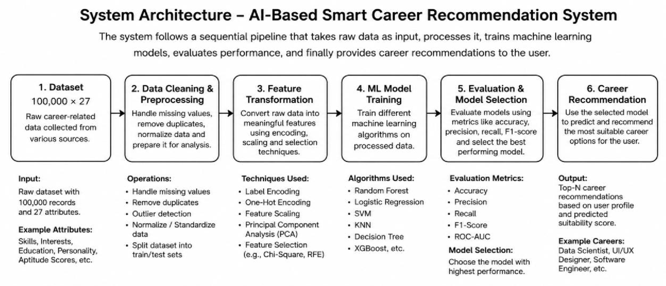

Figure 3.1 – System Architecture
The architecture connects the dataset, pre-processing, feature transformation, model training, evaluation and final career recommendation stages.

3.2 Data Flow

- Dataset is loaded into the analysis environment.
- Data is inspected and prepared for modelling.
- Feature transformations convert raw attributes into model-ready inputs.
- Training and testing data are used to build and evaluate classifiers.
- The trained model and pre-processing artifacts are persisted.
- The application receives a student profile and applies the saved transformations.
- The classifier produces a career class, which is converted into a human-readable recommendation.

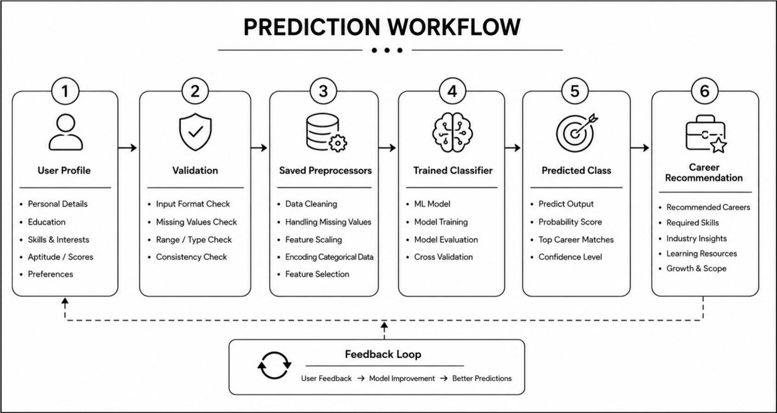
Figure 3.2 – Prediction Workflow

The prediction workflow ensures that user input passes through the same transformation logic used during model development before classification.

3.3 Machine Learning Workflow

• The project implements supervised multi-class classification. The three evaluated models are Logistic Regression, Decision Tree and Random Forest. The model comparison is based on standard classification metrics.

3.4 Module Design

Module | Main Responsibility
Data Ingestion | Load and inspect the CSV dataset
Data pre-processing | Prepare features and encode/scale values
EDA | Generate distribution and relationship visualizations.
Model Training | Train multiple classifiers
Model Evaluation | Measure accuracy, precision, recall and F1
Model Persistence | Model Persistence
Recommendation | Map prediction to career category
Application | Provide user-facing prediction

3.5 Prediction Logic

• Prediction follows this sequence: input profile → validation → selected-feature extraction → categorical encoding/scaling → trained classifier → target decoding → career recommendation.

3.6 Security and Validation Considerations

- Validate input types and allowable ranges.
- Avoid accepting unexpected categorical values without handling.
- Keep model artifacts protected from unauthorized modification.
- Do not expose sensitive user data unnecessarily.
- Display recommendations with an appropriate disclaimer about uncertainty.

CHAPTER 4 – DEVELOPMENT AND IMPLEMENTATION

4.1 Technology Stack

• Python is the primary implementation language. Jupyter Notebook is used for exploratory analysis and model development. Pandas and NumPy support data manipulation; Scikit-learn supports preprocessing, classification and evaluation; Matplotlib/Seaborn support visualization; app.py provides the application-side workflow.

4.2 Dataset Loading and Inspection

• The supplied CSV contains 100,000 rows and 27 columns. The notebook loads the data into a Data Frame and performs initial inspection before model development.

4.3 Data Preprocessing

• The project uses saved preprocessing components. The supplied model directory contains selected_features.pkl, label_encoders.pkl, target_encoder.pkl and scaler.pkl. These artifacts indicate that feature selection, categorical encoding, target encoding and scaling are part of the prediction pipeline.

4.4 Exploratory Data Analysis

• The project contains eight EDA visualizations. They cover the target career distribution, demographic/academic distributions and relationships between career category and selected skill/activity features.

CODE

# 1. Career Distribution plt.figure(figsize= (12, 6)) career_counts = df['Career'].value_counts() sns.barplot(x=career_counts.values, y=career_counts.index, palette='viridis') plt.title('Distribution of Careers', fontsize=16) plt.xlabel('Number of Students', fontsize=12) plt.ylabel('Career', fontsize=12) plt.tight_layout() plt.savefig('eda_plots/career_distribution.png') plt.show()
print ("✓ Career distribution plot saved")
print ("\nTop 5 Careers:") print(career_counts.head())

OUTPUT
✓ Career distribution plot saved

Top 5 Careers:
Career
AI/ML Engineer 10000
Web Developer 10000
UI/UX Designer 10000
DevOps Engineer 10000
Data Scientist 10000
Name: count, dtype: int64
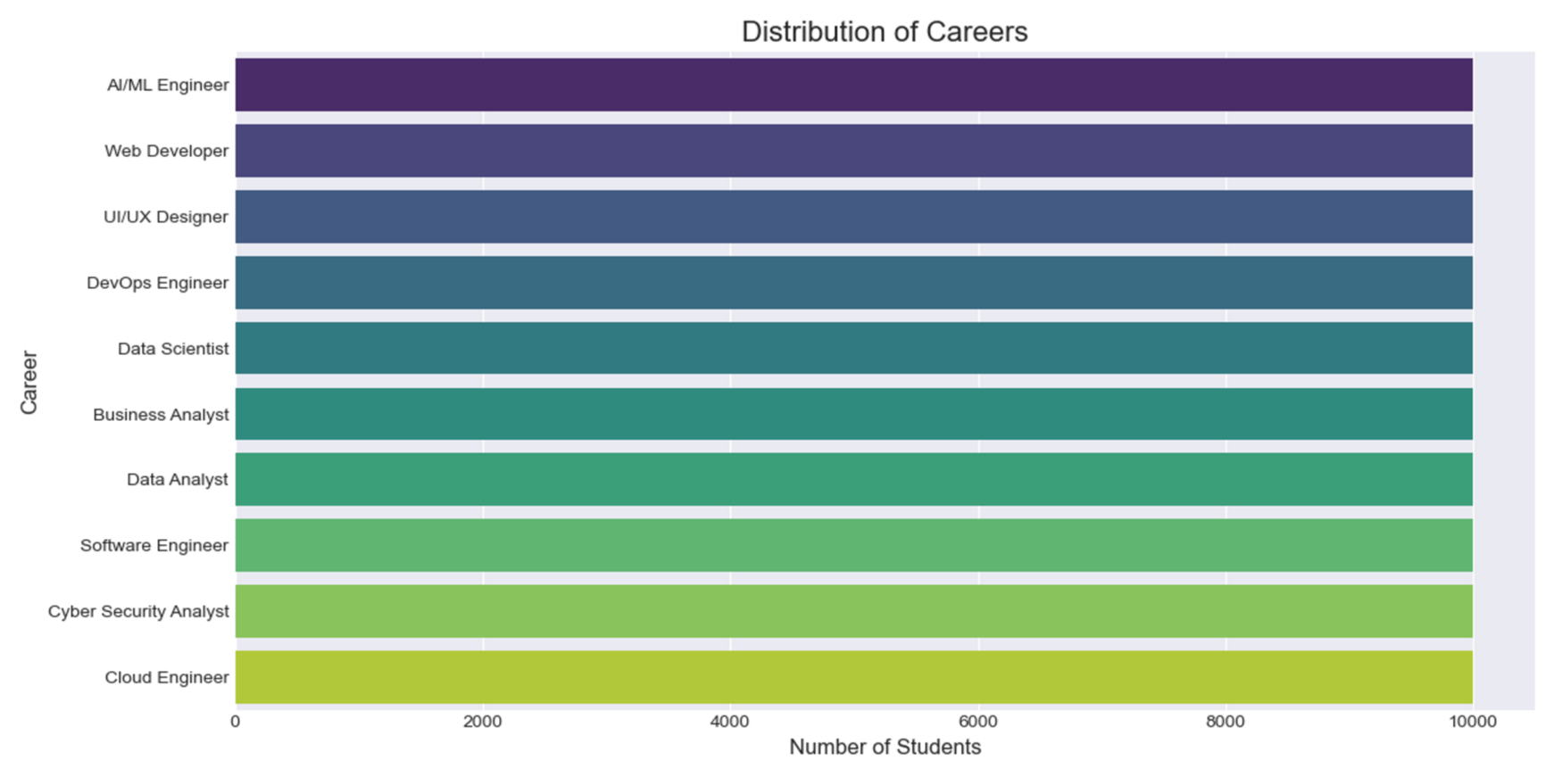

Figure 4.1: Career Distribution

• The career distribution plot shows how records are distributed among the target career categories. This is important for understanding class balance before classification.

CODE
# 4. Gender Distribution plt.figure(figsize=(8, 5)) gender_counts = df['Gender'].value_counts() sns.barplot(x=gender_counts.index, y=gender_counts.values, palette='pastel') plt.title('Gender Distribution', fontsize=16) plt.xlabel('Gender', fontsize=12) plt.ylabel('Count', fontsize=12) for i, v in enumerate(gender_counts.values): plt.text(i, v + 5, str(v), ha='center') plt.tight_layout() plt.savefig('eda_plots/gender_distribution.png') plt.show()
print ("✓ Gender distribution plot saved")

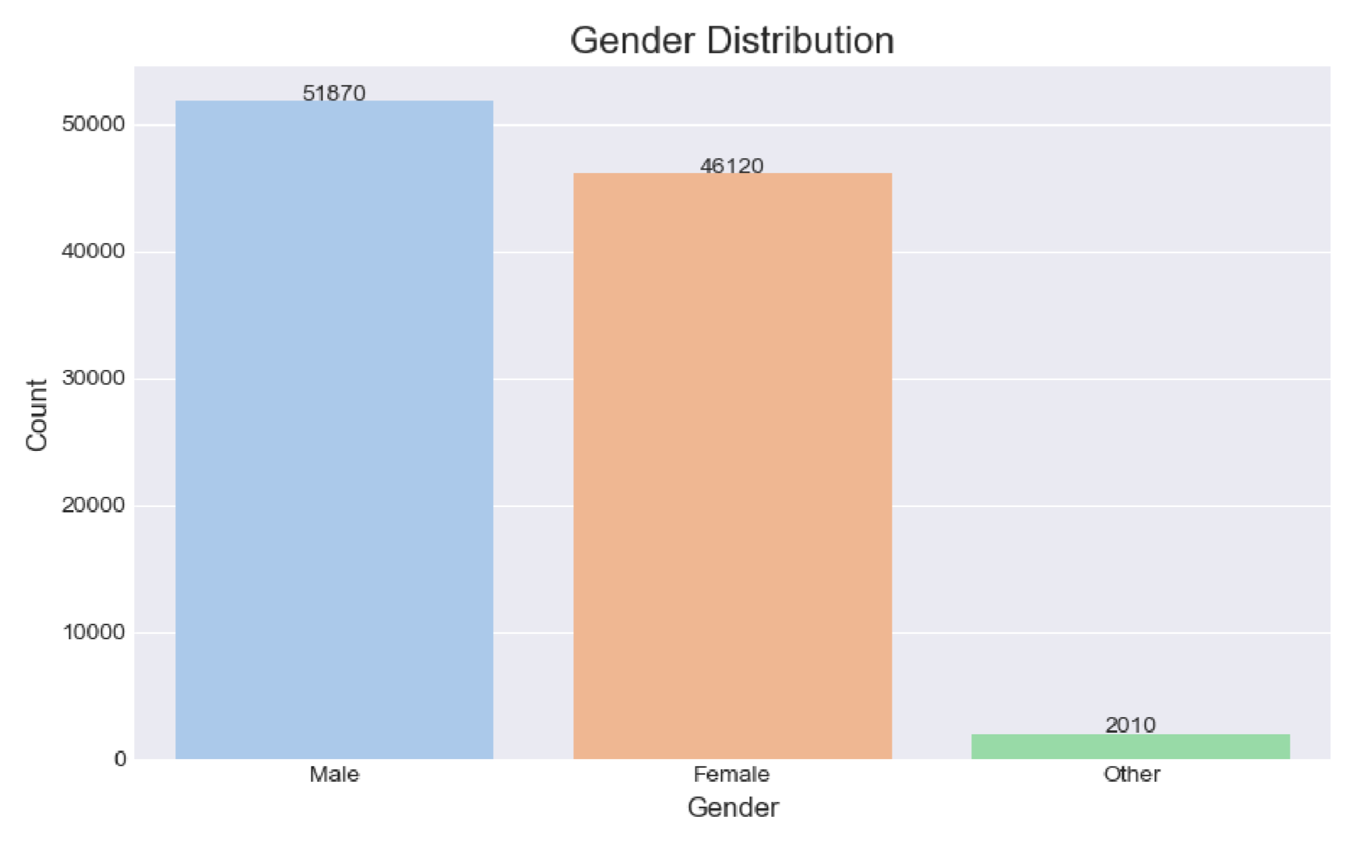

Figure 4.2: Gender Distribution

The gender distribution provides a basic profile-level view of the dataset.
CODE

# 3. Age Distribution plt.figure(figsize= (10, 5)) sns.histplot(df['Age'], bins=15, kde=True, color='green') plt.title('Distribution of Age', fontsize=16) plt.xlabel('Age', fontsize=12) plt.ylabel('Frequency', fontsize=12) plt.tight_layout()
plt.savefig('eda_plots/age_distribution.png') plt.show()
print("✓ Age distribution plot saved")

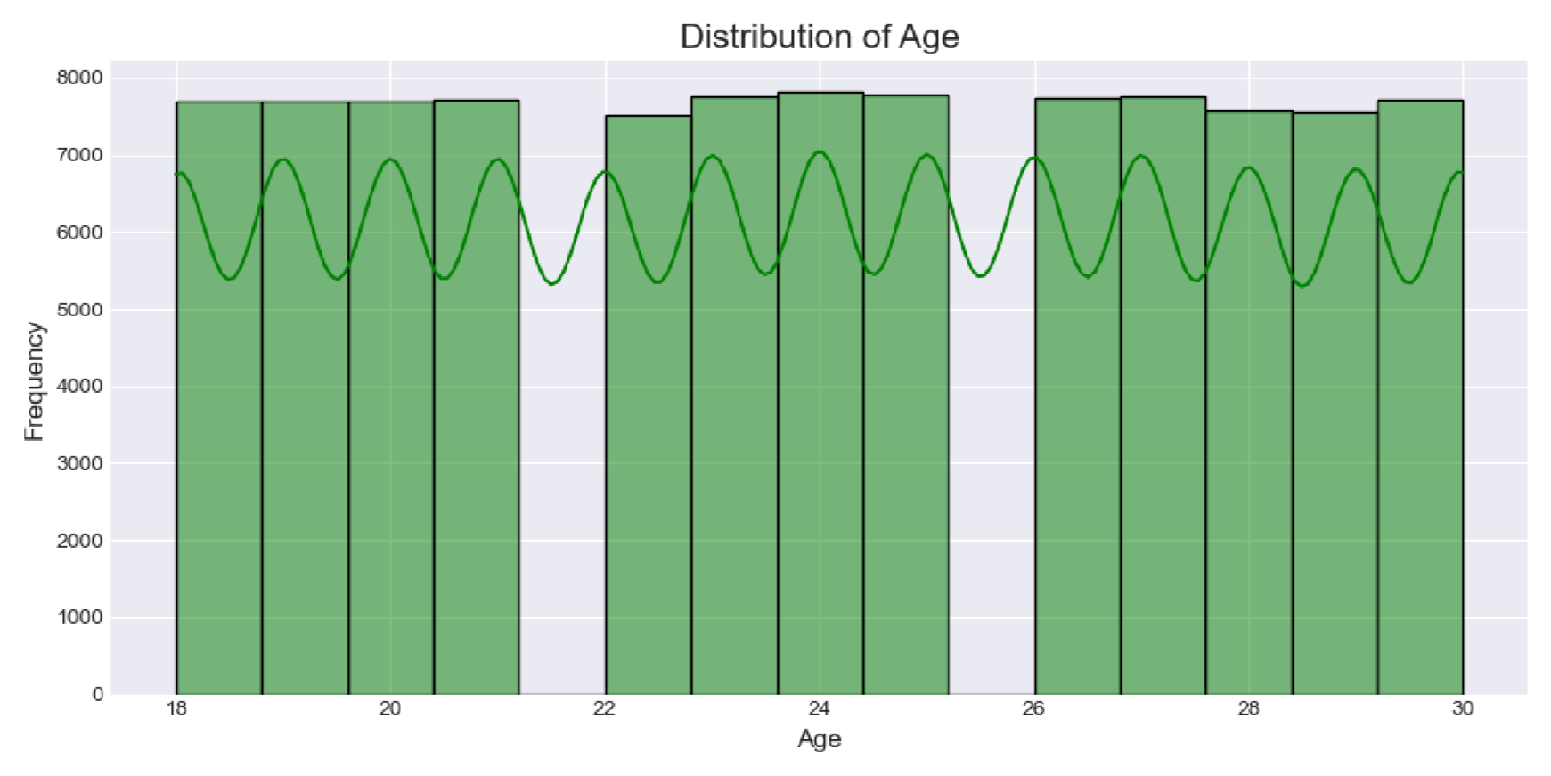

Figure 4.3: Age Distribution

The age distribution summarizes the age range represented in the supplied records.

CODE

# . CGPA Distribution plt.figure(figsize= (10, 5))
sns.histplot(df['CGPA'], bins=20, kde=True, color='blue') plt.title('Distribution of CGPA', fontsize=16) plt.xlabel('CGPA', fontsize=12) plt.ylabel('Frequency', fontsize=12) plt.axvline(df['CGPA']. mean (), color='red', linestyle='--', label=f'Mean: {df["CGPA"]. mean():.2f}') plt.legend() plt.tight_layout() plt.savefig('eda_plots/cgpa_distribution.png') plt.show()
print ("✓ CGPA distribution plot saved")

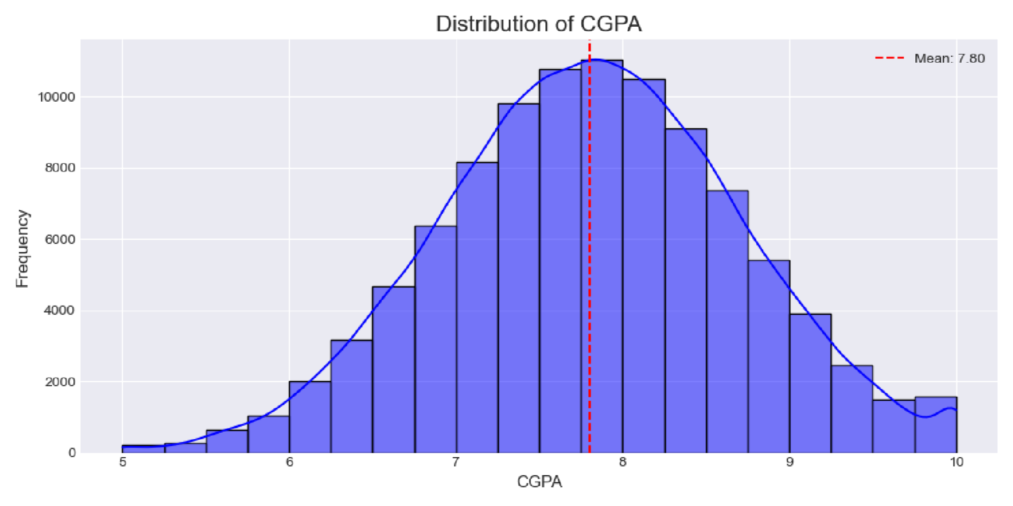

Figure 4.4: CGPA Distribution

The CGPA distribution visualizes academic-performance patterns in the dataset.

CODE
# 6. Career vs Programming Skill plt.figure(figsize=(14, 6)) sns.boxplot(x='Career', y='Programming_Skill', data=df, palette='Set3') plt.title('Career vs Programming Skill', fontsize=16) plt.xlabel('Career', fontsize=12) plt.ylabel('Programming Skill (1-5)', fontsize=12) plt.xticks(rotation=45, ha='right') plt.tight_layout()
plt.savefig('eda_plots/career_vs_programming.png') plt.show()
print("✓ Career vs Programming Skill plot saved")
print("\nInsight: AI/ML and Web Developer roles require higher programming skills")

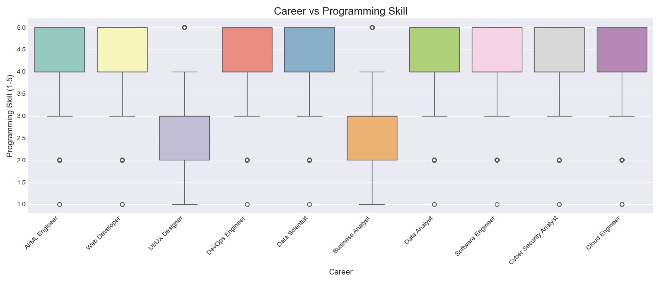

Figure 4.5: Career vs Programming Skill

• This relationship plot examines how programming-skill levels vary across predicted career categories.

CODE

# 5. Career vs CGPA plt.figure(figsize=(14, 6)) sns.boxplot(x='Career', y='CGPA', data=df, palette='Set2') plt.title('Career vs CGPA', fontsize=16) plt.xlabel('Career', fontsize=12) plt.ylabel('CGPA', fontsize=12) plt.xticks(rotation=45, ha='right') plt.tight_layout()
plt.savefig('eda_plots/career_vs_cgpa.png') plt.show() print("✓ Career vs CGPA plot saved")
print("\nInsight: Higher CGPA students tend to get more technical/analytical careers")

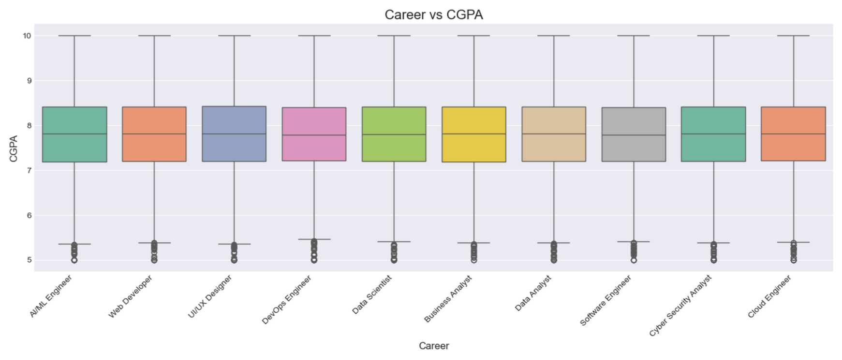

Figure 4.6: Career vs CGPA

This plot examines the relationship between academic performance and career category.
CODE

# 8. Career vs Projects Completed plt.figure(figsize=(14, 6))
sns.boxplot(x='Career', y='Projects_Completed', data=df, palette='viridis') plt.title('Career vs Projects Completed', fontsize=16) plt.xlabel('Career', fontsize=12) plt.ylabel('Projects Completed', fontsize=12) plt.xticks(rotation=45, ha='right') plt.tight_layout() plt.savefig('eda_plots/career_vs_projects.png') plt.show()
print("✓ Career vs Projects Completed plot saved") print("\nInsight: Data Scientist and AI/ML roles have more projects")

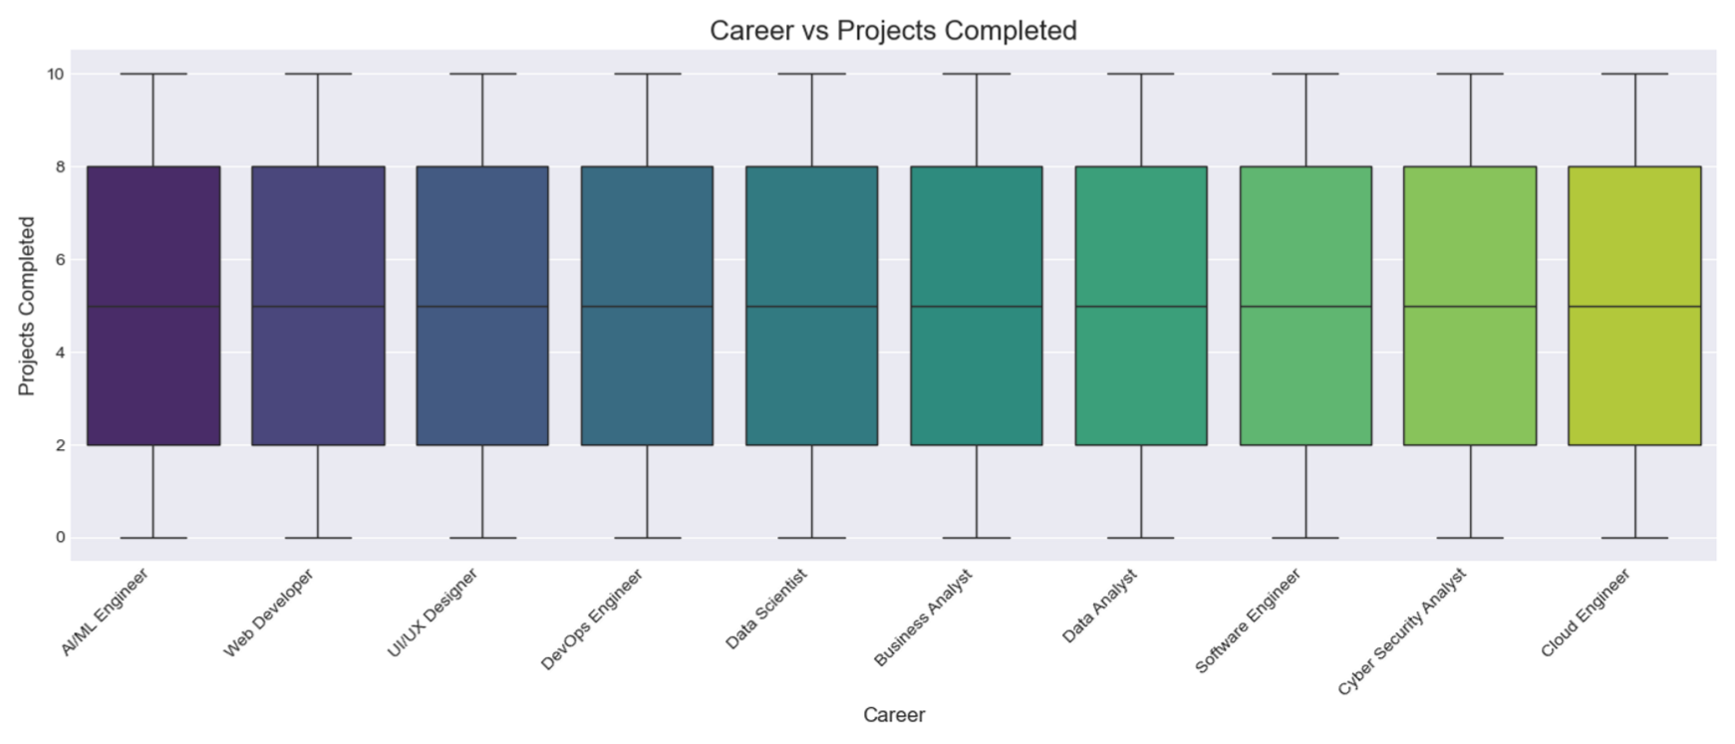

Figure 4.7: Career vs Projects Completed
This visualization relates completed project activity to career categories.

# 7. Career vs Problem Solving plt.figure(figsize=(14, 6))
sns.boxplot(x='Career', y='Problem_Solving', data=df, palette='coolwarm') plt.title('Career vs Problem Solving', fontsize=16) plt.xlabel('Career', fontsize=12) plt.ylabel('Problem Solving (1-5)', fontsize=12) plt.xticks(rotation=45, ha='right') plt.tight_layout() plt.savefig('eda_plots/career_vs_problemsolving.png') plt.show()
print ("✓ Career vs Problem Solving plot saved")

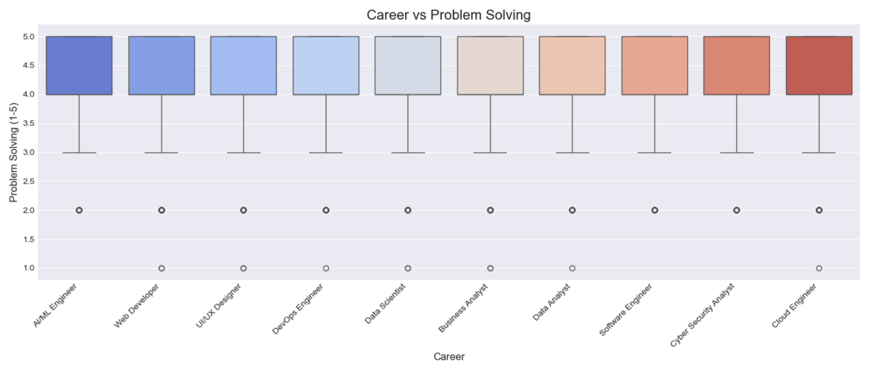

Figure 4.8: Career vs Problem Solving

This plot examines problem-solving skill patterns across career categories.

4.5 Model Training

The supplied project trains three classifiers: Logistic Regression, Decision Tree and Random Forest. Each model is evaluated on the project test data.

4.6 Model Evaluation
Model | Accuracy | Precision | Recall | F1-Score
Logistic Regression | 17.94% | 15.47% | 17.94% | 14.98%
Decision Tree | 14.03% | 14.04% | 14.03% | 14.03%
Random Forest | 17.22% | 15.51% | 17.22% | 16.00%

Interpretation: Logistic Regression has the highest accuracy (17.94%) and is therefore the current best model if accuracy is the selection criterion. Random Forest has the highest F1score (16.00%).
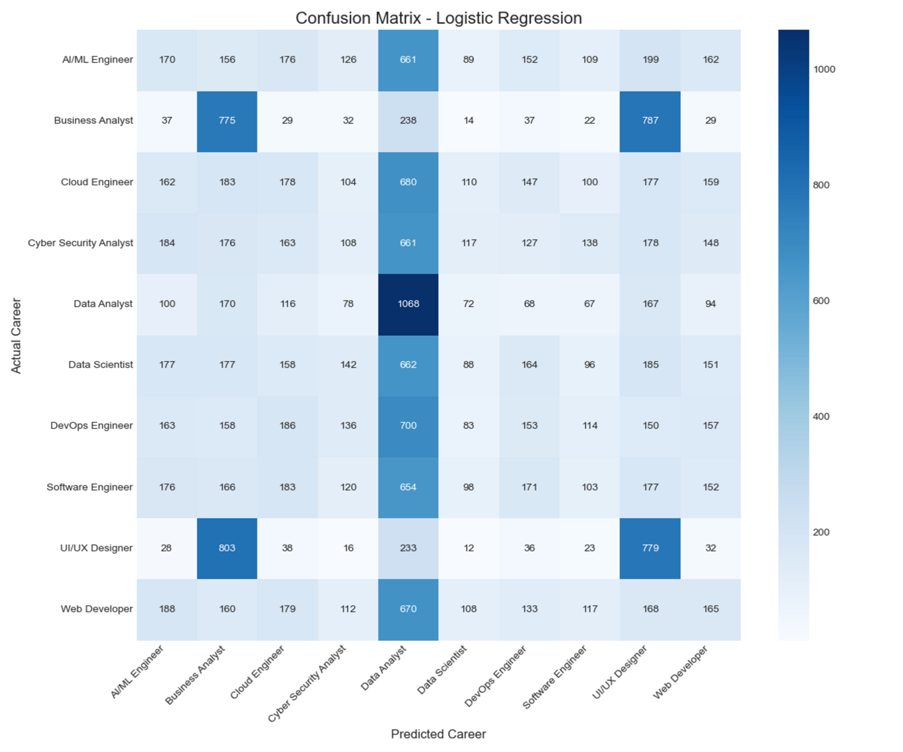

Figure 4.9: Confusion Matrix

The confusion matrix visualizes class-wise prediction performance and shows where actual career categories are being confused with other predicted categories.
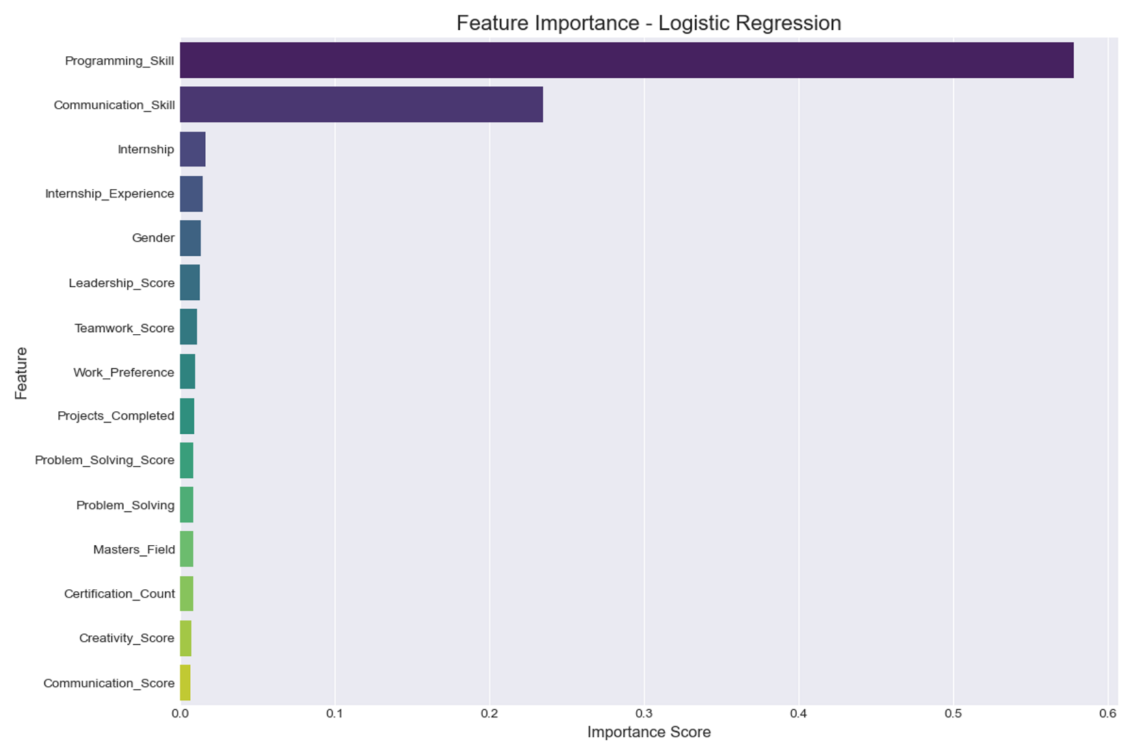

Figure 4.10: Feature Importance

The project’s feature-importance visualization highlights the relative contribution of selected features. Programming Skill and Communication Skill are among the prominent features shown by the supplied analysis.

4.7 Application Layer

• The supplied app.py implements the application-side prediction workflow. It uses the saved model and preprocessing artifacts to transform profile inputs and generate a career-category prediction.
http://localhost:8501/
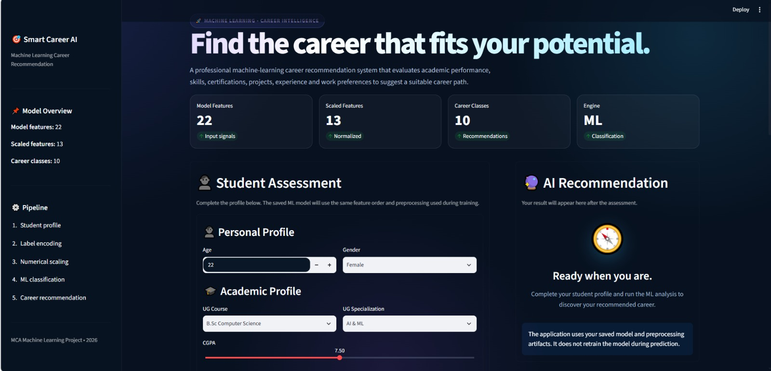

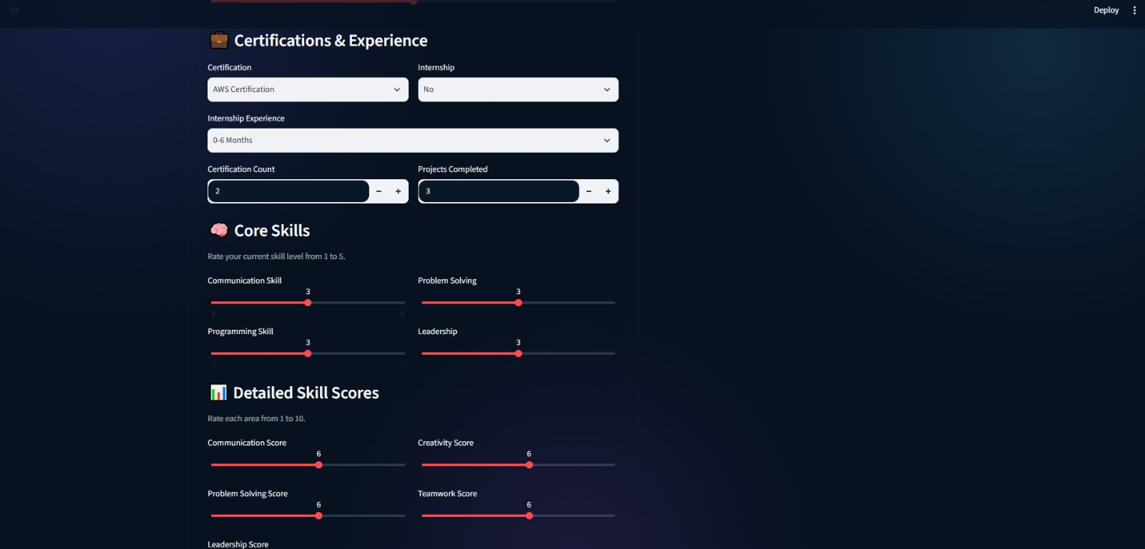



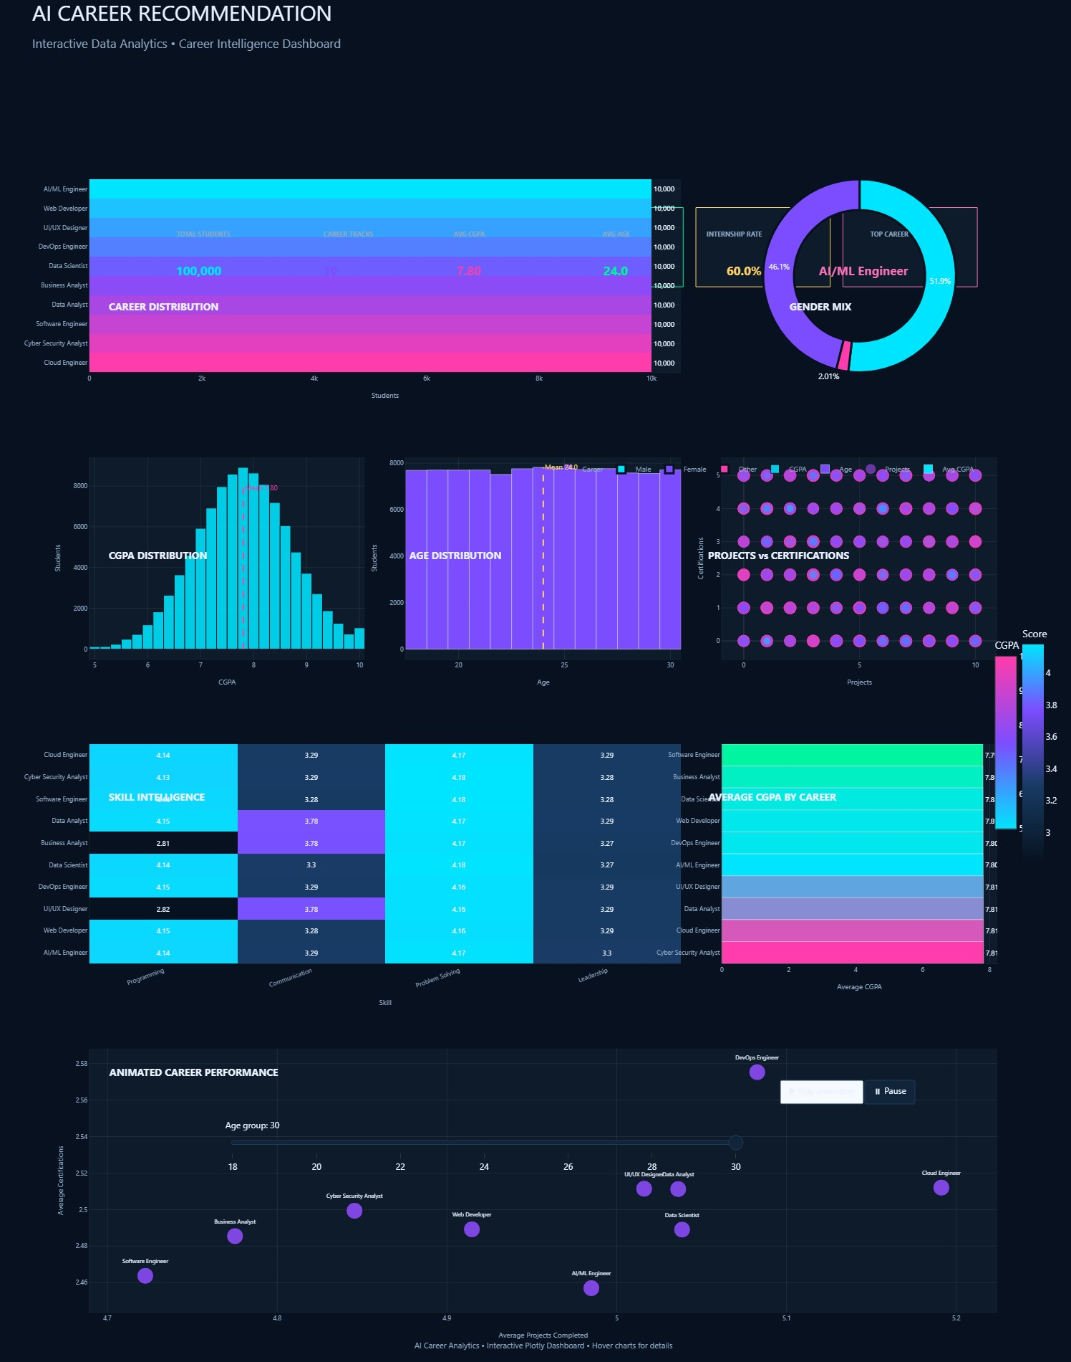
4.7.1 AI Career Recommendation Career Intelligence Dashboard
Figure 4.11: AI Career Recommendation Interactive Dashboard
The interactive dashboard consolidates key analytical outputs of the AI-Based Smart Career Recommendation System, including career distribution, gender mix, CGPA distribution, age distribution, skill intelligence, certifications, projects and career-performance insights. It provides a single visual interface for exploring the dataset and supporting career analysis

4.8 Saved Model Artifacts

Artifact | Purpose
career_model.pkl | Trained career prediction model
selected_features.pkl | Feature subset used during prediction
label_encoders.pkl | Encoders for categorical variables
target_encoder.pkl | Mapping between encoded target and career category
scaler.pkl | Scaling transformation for model inputs

CHAPTER 5 – TESTING AND RESULTS

5.1 Testing Strategy

• Testing covers data ingestion, preprocessing, model training, metric generation, artifact loading and prediction. Classification quality is measured using accuracy, precision, recall and F1-score. The confusion matrix provides additional class-level insight.

5.2 Test Cases

ID | Test Area | Action | Expected Result | Observed Result
TC-01 | Dataset  Loading | Load CSV | Dataset available | 100,000 × 27 dataset loaded
TC-02 | Target | Identify target field | Career target identified | Career target available
TC-03 | Preprocessing | Transform features | Model-ready input | Artifacts available
TC-04 | Model 1 | Train Logistic  Regression | Model trains | Completed
TC-05 | Model 2 | Train Decision Tree | Model trains | Completed
TC-06 | Model 3 | Train Random Forest | Model trains | Completed
TC-07 | Evaluation | Compare metrics | Best model identified | Logistic Regression highest accuracy
TC-08 | Prediction | Submit profile | Career category returned | Sample recommendation generated
TC-09 | Persistence | Load saved artifacts | Pipeline restored | Required pickle files available

5.3 Model Comparison

• The model results are relatively low across all three classifiers. This means the present system is better interpreted as a functional academic prototype and baseline than as a high-confidence recommendation engine.

5.4 Confusion Matrix

• The confusion matrix provides a detailed view of which career classes are predicted correctly and which are confused with others. The amount of off-diagonal activity in the supplied result is consistent with the relatively low overall accuracy.

5.5 Feature Analysis

• The supplied feature analysis highlights Programming Skill and Communication Skill among the more prominent predictors. This is consistent with the project's objective of combining technical and interpersonal attributes for career classification.

5.6 Sample Recommendation

• The supplied project demonstrates a sample prediction in which the system returns “Data Analyst” as the recommended career category. This validates the end-to-end prediction flow.

5.7 Result Interpretation

• The most important conclusion from the current evaluation is not only which model performs best, but also that the measured performance needs improvement. Future work should focus on class balance, label quality, feature engineering, hyperparameter tuning and more robust validation before relying on recommendations for real decisions.

• CHAPTER 6 – PROPOSED ENHANCEMENTS

6.1 Data Improvements

- Review target labels and class definitions.
- Check class balance and apply appropriate balancing methods.
- Investigate duplicate/noisy records.
- Expand features that represent interests, certifications and domain preferences.
- Use carefully validated data from multiple sources if available.

6.2 Model Improvements

- Use stratified cross-validation.
- Perform systematic hyperparameter tuning.
- Evaluate gradient boosting and other ensemble approaches.
- Experiment with feature engineering and dimensionality reduction where justified.
- Compare macro and weighted metrics in addition to accuracy.
- Add probability/confidence estimates where supported.

6.3 Recommendation Features

- Return top-3 or top-5 career options.
- Explain why each career was recommended.
- Show required skills and current skill gaps.
- Generate a personalized learning roadmap.
- Recommend courses, certifications and project ideas.
- Add resume upload and automatic skill extraction.

6.4 Deployment Improvements

- Deploy the application to a cloud environment.
- Add authentication and secure data storage if user accounts are introduced.
- Add model/version tracking.
- Monitor prediction quality after deployment.
- Create an admin dashboard for dataset/model updates.

CHAPTER 7 – CONCLUSION

- The AI-Based Smart Career Recommendation System demonstrates a complete supervised machine-learning workflow for career-category recommendation. The project combines a large dataset with preprocessing, exploratory analysis, multiple classification models, evaluation metrics, model persistence and an application layer.
- The current evaluation compares Logistic Regression, Decision Tree and Random Forest. Logistic Regression achieves the highest observed accuracy of 17.94%, while Random Forest achieves the highest F1-score of 16.00%. The project therefore establishes a measurable baseline and a working academic prototype.
- At the same time, the current model performance is not strong enough to justify highconfidence real-world career decisions. The next development stage should focus on improving the dataset and modelling pipeline and adding recommendation explanations, skill-gap analysis and personalized learning support.
- With these improvements, the project can evolve from a classification prototype into a more comprehensive AI-assisted career guidance platform.

